|  |  |
| --- | --- |
| **Project:** Aaron Crose |  |
| **Course:** CSD 380 |  |
| **Description:** Module 4.2 Assignment - Test Plan |  |
| **Date:** 2024/11/14 |  |

To complete the test case plan, fill out the information for Project, Course, Description and Date in the header below.

.

**TABLE OF CONTENTS**

**<DESCRIPTION>** 2

**<DESCRIPTION>** 2

**<DESCRIPTION>** 3

1. **Accessing the Website**
   * **Developer: Aaron Crose**
   * **Peer Tester: Joe Huffer**
   * **Steps**:
     + 1. Navigate to <https://buwebdev.github.io/todo/>.
          - Test notes: yes
          - A screenshot of a computer

            Description automatically generated
       2. Confirm the page loads without errors.
          - Test notes: yes
          - A screenshot of a computer

            Description automatically generated
       3. Refresh the browser.
          - Test notes: yes
          - A screenshot of a computer

            Description automatically generated
       4. Confirm the page reloads correctly. With Todo tasks.
          - Test notes: yes
          - A screenshot of a computer

            Description automatically generated

**Expected Result**: The website should load and reload correctly without errors.

Tester comments: Site loads when navigated to. Site also refreshes and displays without error.

1. **Create a Todo Task**
   * **Developer: Aaron Crose**
   * **Peer Tester: Joe Huffer**
   * **Steps**:
     + 1. Click the "Add Task" button.
          - Test notes: yes
          - 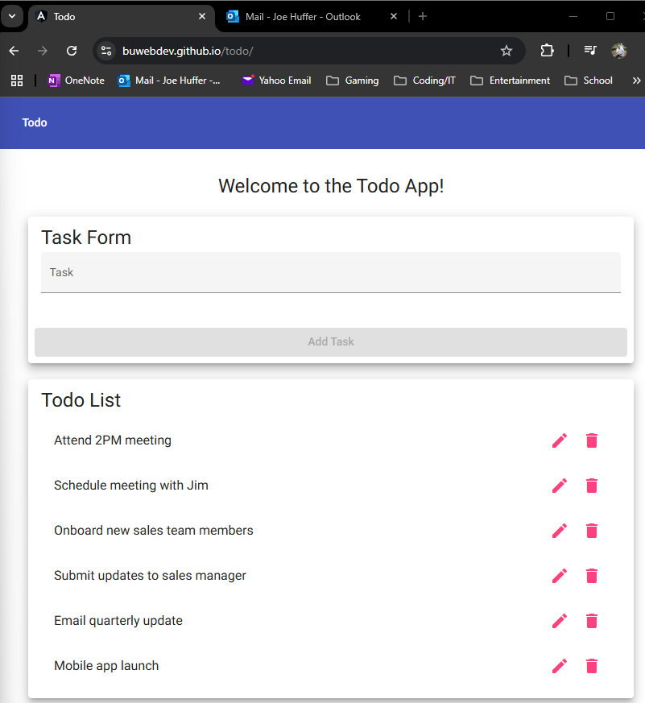
       2. Enter a valid task name into the form field.
          - Test notes: yes
          - A screenshot of a computer

            Description automatically generated
       3. Submit the form.
          - Test notes: yes
          - A screenshot of a computer

            Description automatically generated
       4. Verify the task is added to the todo list.
          - Test notes: yes
          - A screenshot of a computer

            Description automatically generated

**Expected Result**: New tasks are successfully added and displayed in the list.

Tester comments: Notes on step 1, Add Task button remains grayed out until an input is placed in the line above it. Once step detailing adding an input and submitting, contents displayed on the application properly at bottom of list.

1. **Delete a Todo Task**
   * **Developer: Aaron Crose**
   * **Peer Tester: Joe Huffer**
   * **Steps**:
     + 1. Select an existing task.

Test notes: yes

* + - 1. Click the "Delete" button.

Test notes: yes

* + - 1. Confirm the deletion in the popup dialog.

Test notes: yes

* + - 1. Verify the task is removed from the list.

Test notes: yes

**Expected Result**: The selected task should be removed from the todo list.

Tester comments: Quick note, there is no confirmation of deletion under step ‘confirm the deletion..’ as there is no implemented confirmation step. Once trash can (delete) is selected on the item, the item deletes immediately with no other dialogue box or function. Item ‘valid task name’ was selected and properly deleted from list via steps listed.

1. **Edit a Todo Task**
   * **Developer: Aaron Crose**
   * **Peer Tester: Joe Huffer**
   * **Steps**:
     + 1. Select an existing task.
          - Test notes: yes
          - A screenshot of a computer

            Description automatically generated
       2. Click the "Edit" button.
          - Test notes: yes
          - A screenshot of a computer

            Description automatically generated
       3. Modify the task details and save the changes.
          - Test notes: yes
          - A screenshot of a computer

            Description automatically generated
       4. Confirm the task updates correctly in the list.
          - Test notes: yes
          - A screenshot of a computer

            Description automatically generated

**Expected Result**: The task should be updated with the new details.

Tester comments: Edit function works as expected. Item ‘Attend 2PM meeting’ was selected and modified to ‘Attend 2PM meeting Test Edit’ once saved. Verified task updates correctly in list.

1. **Handling Invalid URLs**
   * **Developer: Aaron Crose**
   * **Peer Tester: Joe Huffer**

* **Steps**:
  + - 1. Navigate to an invalid URL within the application <https://buwebdev.github.io/todo/invalid>
         * Test notes: yes
         * A screenshot of a computer

           Description automatically generated
      2. Confirm the custom 404 error page is displayed.
         * Test notes: yes
         * A screenshot of a computer

           Description automatically generated

**Expected Result**: The custom 404 error page should be shown

Tester comments: Using invalid link provided, opened a new tab and navigated to <https://buwebdev.github.io/todo/invalid>. Link provided redirects to: <https://buwebdev.github.io/todo/not-found> confirming custom 404 error page displays on invalid url.

1. **Form Validation**
   * **Developer: Aaron Crose**
   * **Peer Tester: Joe Huffer**
   * **Steps**:
     + 1. Attempt to submit a task form without entering a todo item.
          - Test notes: yes
          - A screenshot of a computer

            Description automatically generated
       2. Attempt to submit an edit form without entering a todo item.
          - A screenshot of a computer

            Description automatically generatedTest notes: yes

**Expected Result**: An error message should prevent form submission and inform the user of the required fields.

Tester comments: Marking both steps as “yes” (pass) but was slightly unclear on step 2 if you wanted us to edit an existing item or edit an item we haven’t added yet. Regardless on the answer, we are not able to perform the steps, and the expected outcome of nothing being altered is achieved.

|  |  |  |  |  |
| --- | --- | --- | --- | --- |
| Step | Action | Expected Results | Developer Pass/Fail | Tester Pass/Fail |
| 1 | Visit <https://buwebdev.github.io/todo/>. | Website loads without error   |  | | --- | |  | | yes/no | yes |
| 2 | Create a todo task | New tasks are added and displayed on list | yes/no | yes |
| 3 | Delete a todo task | The selected task is removed from the list. | yes/no | yes |
| 4 | Edit a todo task | Task is updated with the new details. | yes/no | yes |
| 5 | Handling invalid URLs | An error page is displayed for the user. | yes/no | yes |